**Brooklyn torah gazette**

**For parshas ki sisa 5780**

Volume 4, Issue 27 (Whole Number 179) 18 Adar 5780/ March 14, 2020

**Printed L’illuy nishmas Nechama bas R’ Noach, a”h**

**Stop Otherizing Haredi Jews**

**“Ultra-Orthodox” is a**

**Label that Should be Retired.**

**By Avi Shafran**

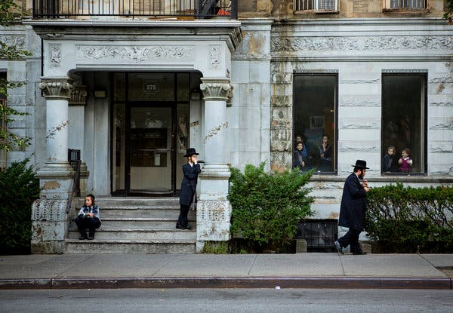

***Williamsburg, Brooklyn, 2014. Photo Credit...Jessica Lehrman for The New York Times***

In the spring of 2016, President Barack Obama signed a bill eliminating dated references to racial or ethnic minorities that had remained in parts of federal regulations. “Negro” would be replaced with “African-American,” “Oriental” with “Asian-American or Pacific Islander” and so on. It was a long-overdue recognition that the meanings that words carry matter — especially when applied to minority groups.

It’s now generally accepted that racial, ethnic and religious groups determine how they wish others to refer to them. This is true not only in government documents but also in popular media and polite conversation.

There’s an exception, though, applied to my group — a different standard. We’re constantly labeled “ultra-Orthodox,” against our wishes.

We’re your neighbors, recognizable by our men in dark suits and black hats (for the subset among us called Hasidim, fur hats on the Sabbath and holidays), our women in modest dress and wigs or with kerchief hair coverings.

We oppose the label “ultra” as anyone would. What does “ultra” bring to mind in, say, politics? Does “ultraconservative” conjure images of Ambassador Nikki Haley and John McCain, or of Pat Buchanan and Steve Bannon? What do we mean when we call an investment “ultra-risky”? Or a race an “ultra-marathon”? We mean something that is extreme, beyond normal or beyond the mainstream.

Haredim (the Hebrew word we prefer, signifying religious devoutness) don’t buy into some elements of modern culture, and our value system places family, textual study and religious observance above certain material goals.

But that doesn’t make us extremists. We don’t rail against others and have no plans, as some religious extremists do, to harm or impose our will on anyone. We’re Orthodox, religiously observant Jews, but no more “ultra” than a typical observant Catholic, Mormon or Muslim.

Being tarred with the prefix “ultra” is only part of the problem. We’re demeaned in other ways, too. Enjoined by our faith to travel on the Sabbath only on foot, HarediJews tend to live near their synagogues, and what naturally results are Haredi neighborhoods and communities.

Why, when we buy homes in new communities, are we so often portrayed as invaders? We fully understand that the character of a neighborhood changes when members of a new ethnic or religious group arrive. We’ve been there ourselves. But no one should be able to discriminate against us in the home-buying process.

We also take our civic responsibility and legitimate self-interests seriously, so we vote in higher-than-average proportions. We embrace certain values and goals, and seek to promote them at the ballot box. That’s the American democratic process at work.

Yet, when we exercise our right to vote in local elections, where our small numbers can still have measurable impact, we are routinely described as a “bloc,” a term that carries a sinister whiff of creepiness. Think “Soviet bloc” or “Communist bloc.” There’s often nonjudgmental talk of “the black vote” and “the Hispanic vote.” Why are Haredim a “bloc”?

There are other subtly disparaging tropes about Haredim as well, telegraphed not necessarily by specific words like “ultra” and “bloc,” but by negative stereotyping and harmful canards. These, too, are as lamentable as they are misleading. Haredim may all seem to dress similarly, but we are individuals, with individual, independent characteristics, views and skills.

Anti-Semitism, which always lurks beneath the surface of societies, has of late reared its ugly head. It has manifested in the streets of Brooklyn and in racist corners of the internet. And the targets of this hatred are often Haredim, visibly distinguishable Jews.

While there’s no direct line between subtle “othering” and physical violence, disparagement, even only in words, adds moisture to the dark cloud of prejudice. And sufficiently saturated, that cloud can yield, as a famous Jewish poet once put it, a hard rain.

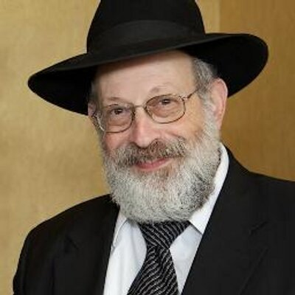

Avi Shafran is the director of public affairs for Agudath Israel of America, an author and a columnist for Hamodia.

*The Times is committed to publishing*[*a diversity of letters*](https://www.nytimes.com/2019/01/31/opinion/letters/letters-to-editor-new-york-times-women.html)*to the editor. We’d like to hear what you think about this or any of our articles. Here are some*[*tips*](https://help.nytimes.com/hc/en-us/articles/115014925288-How-to-submit-a-letter-to-the-editor)*. And here’s our email:*[*letters@nytimes.com*](mailto:letters@nytimes.com)*.*

*Reprinted from the February 20, 2020 website of The New York Times. A version of this article appears in print on Feb. 21, 2020, Section A, Page 27 of the New York edition with the headline: I Am a Haredi Jew, Not an Extremist.*

**Rav Avigdor Miller On**

**Prayer and Teshuva to**

**Be Saved from Hitler**

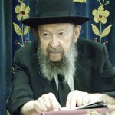

**QUESTION:** Why didn't the *gedolim* in Europe gather all Jews together for fasting and *teshuva* the same way as Mordechai did when he saw a Holocaust coming?

**ANSWER:** And the answer is the *gedolim* in Europe didn't have any influence at all, and I can testify to that. I'll give you a *mashal*. I was in Slabodka which was a suburb of Kovna. Kovna was the main town of Lithuania and the Kovna Rov was the most important Torah authority in all of Lithuania.

And yet, no newspaper would publish anything that he said. If he would come out with a proclamation that we should pray to Hashem, they'd all ridicule him. At most, if he would have the boldness, he could print up some leaflets and post them in some *batei midrashos.* But the people didn't come to the *batei* *midrashos* anyhow — very few people came, so who would listen to him?

I'm sure that he prayed himself. I'm sure that in the Slabodka Yeshiva they prayed. I was present in Slabodka when Hitler marched into Sudetenland, and they prayed; oh, how they prayed. But outside of the *yeshiva*, the populace was hostile to the *yeshiva* boys. They despised the *yeshiva* boys; they called them *patronet. P*atronet means parasites.

And that’s because the Jewish public was in the hands of the newspapers; everybody read the newspapers. And the newspapers were against keeping the Torah, they despised the Torah. The people were poisoned – even the *shomrei Shabbos*Jews were poisoned by the newspapers.

So how could the Torah leaders have anything? The Agudas Yisroel had a little newspaper that came out once a month – once a month! Mizrachi had a little rag that came out once in two weeks - they had no influence at all. And therefore the *rabbonim* couldn't call the Jews and summon them to do *teshuva* in Europe – it was out of the question.

And you think it was better in Hungary? No, it wasn't much better there. In Hungary the Reformers were the leaders. Everywhere, the Reform rabbis were the ones who had the influence over the public, and therefore it wasn’t possible. They didn’t call the people to repentance because the people didn’t want to be called —and therefore the *yeshua* didn't come.

*Reprinted from the January 30, 2020 email of Toras Avigdor adapted from Tape #731.*

**The Shmuz onParshas Ki Sisa**

**The Merit of Others**

**By Rabbi Bentzion Shafier**

**Founder of TheSmuz.com**

“And HASHEM spoke to Moshe saying, “Go down, for your nation that you have brought up from Egypt, has sinned”. Shemos 32:7

Moshe Rabbeinu was the single greatest human being who ever lived. The Rambam tells us that of all the navi’im, he alone was able to speak to HASHEM directly. Normally, a prophet must go into an altered state of consciousness to experience HASHEM. Otherwise the experience would cause sensory overload, and he would die. Moshe was able to speak to HASHEM in a totally clear, conscious state of mind. At any time, he could approach HASHEM and speak, experiencing HASHEM as I do a neighbor or friend. Moshe was also granted access to the entire Torah, in all its depths and its secrets.

Right after the sin of the Golden Calf, HASHEM told Moshe, “Go down.” Rashi explains this didn’t simply mean, “Go down to see what the nation is up to. Rather, “Go down”, from your greatness. You have lost access to the upper worlds. The ability to enter the Bais Din of Heaven has been taken from you. I only gave you that access because of the Klal Yisroel. They are no longer worthy, so you must go down.”

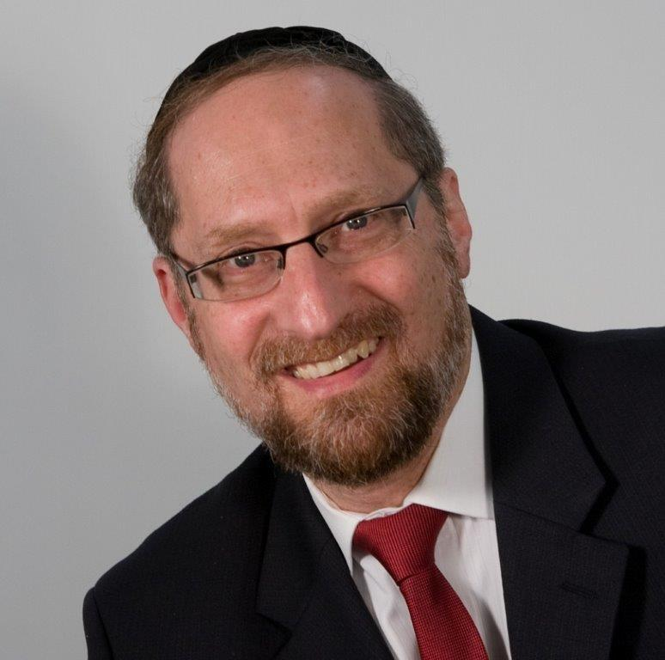

**Rabbi Bentzion Shafier**

This Rashi becomes difficult to understand when we take into account that Moshe was on a fantastic level because of his actions and ways. He spent his life dedicated to serving HASHEM. Clearly, this access to the upper worlds and his ability to perceive and understand Torah were things that he had earned because of his hard work. So why should they be taken from him?

The answer to this can be better understood by focusing on the relationship we have to one another.

**Two Systems in the World to Come**

The Chovos Ha’Levovos explains that there are two systems of measurement in the World to Come, the internal and the external. The internal system is based on my personal growth: improving my character traits, increasing my awareness of HASHEM, learning Torah… The external system is based on merits outside of myself: how much I affected others and the influence that I had on people. These are accomplishments that don’t directly change my state of spirituality, but because I was the cause of them, they are credited to me.

As an example, the Chovos Ha’Levovos describes two individuals. The first has sterling character traits, is steeped in Torah knowledge, and is so great that he can be compared to the angels above. The second individual is but a plain person. He’s nowhere near as developed in his service to HASHEM as the first man. Yet when they both come to the World to Come, the second individual will tower over the first.

Why? Because the first person brings with him his own merit while the second toiled to improve others. Therefore, he has his own merit plus the merits of all of those whom he helped.

A moshol to this would be looking at how people become wealthy. In 2001, Microsoft Corporation reported 40 billion dollars in excess cash. That means money that was not needed for operating expenses, research and development, or marketing — extra money. Bill Gates, as the largest single shareholder of the company, had become one of the richest men in the world with billions of dollars in discretionary income. It would take a successful lawyer, doctor, or account 10,000 years of hard work to earn that kind of wealth. The question is, how does a person acquire so much money?

The answer is he cannot. No single man can ever earn that type of prosperity. The secret to building wealth is to have other people on your payroll. A successful dentist can drill, fill and bill, but he is only one man doing a job. Bill Gates had 20,000 workers in his employ. In a good market, with a good product and a team of thousands churning it out, your profits will be multiplied exponentially, and you can realize that which no single individual can even dream of.

This is how the Chovos Ha’Levavos explains these two individuals. The first person may have been great, but he was working for himself. He was a one-man operation. While he may have attained prominence, it was limited. The second man had many people in his employ. Because of him, many people grew closer to HASHEM. And since their growth came about because of him, he is credited with it, so he is fantastically rich in merit.

**Moshe was Working for the Klal**

The answer to this Rashi seems to be that when it comes to aiding others in their spiritual growth, not only does HASHEM reward someone with the external merit of what others accomplished, He gives the person all the tools he needs to accomplish his mission. Moshe was the representative of the multitude and was therefore allowed access to the highest level of Torah knowledge and understanding — not in his own merit, but in the merit of the entire nation.

As important as Moshe Rabbeinu was, he was a man, and man isn’t allowed access to the upper worlds. When the Jewish nation was deserving, Moshe represented them and therefore was allowed to enter the Heavens. He was the conduit for bringing Torah to the multitudes. Once the Jews fell from that level, they were no longer worthy, so he as their shaliach was no longer permitted in Shamayim. It wasn’t as a punishment to him, but a reality. He no longer had the merit of that great nation catapulting him to those heights.

We see a powerful concept from this Rashi. When you help other people grow, not only do you receive reward for everything that they accomplish, you receive S’yata D’Shmaya to do things that you might not have been able to otherwise. Whether as a rebbe teaching a difficult Gemarah, a worker for the klal taking on a bold project, or a parent trying to create a wholesome environment for his or her family, the merit of the entire group works in your favor, and you will be able to do things that would otherwise be unthinkable.

*Reprinted from this week’s website on TheShmuz.com This is an excerpt from the [Shmuz on the Parsha book](https://theshmuz.com/product/shmuz-on-the-parsha-book/).*

**How Could the Jews Make the Mistake of the Golden Calf**

**From the Talks of the Lubavitcher Rebbe**

**Rabbi Menachem Mendel Schneerson, Zt”l**

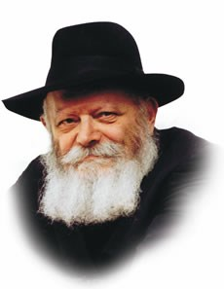

This week's Torah portion, Ki Tissa, contains one of the most misunderstood occurrences to be recorded in the Torah -- the sin of the Golden Calf.

This sin was so great that its consequences are still being felt today, thirty-three hundred years later. For, as a result of the sin, G-d promised that every punishment that would ever befall the Jewish people would contain an element of chastisement for this grievous transgression.

And yet, as it appears in the Written Torah (without the accompanying commentary), the entire account is illogical and difficult to understand. How could the same Jewish people who had just left Egypt under miraculous circumstances, received the Torah at Mount Sinai amidst open miracles and actually heard the voice of G-d utter the first two of the Ten Commandments, stoop so low as to worship a molten image?

Closer study reveals, however, that the Jewish people were not seeking a substitute for G-d in the Golden Calf; what they desired was a substitute for Moses, as expressed in the verse, "And the people saw that Moses was delayed in coming down ...and they said [to Aaron]: Get up, make us a god...for this man, Moses, who has taken us out of the land of Egypt, we do not know what has become of him."

Without Moses, the Jewish people were in a quandary. Moses was the intermediary that connected them to G-d Above, as it states, "I stand between G-d and you." Moses was the medium through which the Children of Israel were freed from Egypt and through whom they received the Torah, to the point where "the Divine Presence spoke from his throat."

Moses is referred to as "a man of G-d," for despite the fact that he was mortal, Moses existed on a spiritual plane on which he was totally united with the Divine. His function as intermediary between man and G-d served to strengthen the Jews' belief in the Creator, for it is difficult to believe in a G-d one cannot see. When the Jews beheld a human being on such a G-dly level, it strengthened their faith in G-d and connected them to Him in a tangible manner.

In this light, the mistake they made is far easier to comprehend. When Moses did not reappear when they expected him, the Jewish people feared they had lost the means by which they bound themselves with the Infinite. They rightly understood that such an intermediary needs to be completely united with G-d; having just witnessed the giving of the Torah on Mount Sinai, at which G-d descended in a "supernal chariot" bearing the face of an ox, they decided to forge a calf of gold that would closely resemble it.

The Jewish people were correct in their recognition of the need for an intermediary between man and G-d in the form of a G-dly human being; there was also nothing wrong with their choice of an inanimate object to draw holiness down into this world (G-d's voice would later issue forth from between the cherubim -- fashioned in the form of two angels -- above the holy ark in the Sanctuary).

Rather, their error was in taking into their own hands a matter which can only be determined by G-d. Only G-d has the authority to decide how His holiness will be transmitted; only He may choose the correct medium.

*Reprinted from the Issue #356 of L’Chaim Weekly (Parashat Ki Tisa 5755/1994)*

**Rabbi Berel Wein**

**On Parashas Ki Tisa**

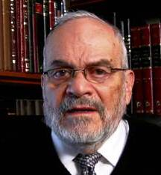

One of the more mystical rituals in the *mishkan* was the *ktoret* – the offering of incense on the altar. The incense, when burned by fire, provided a fragrant cloud of smoke that permeated the tent of the *mishkan*. The Torah is very exact and detailed in describing the ingredients and formula that formed the *ktoret*in the *mishkan* and later in the Temple, which produced this powerful fragrance. The Talmud states that when the incense was being prepared in the Temple in Jerusalem the goats pasturing downwind in Jericho sneezed!

There is no doubt that the incense did provide a very strong and pungent fragrance, though nowhere is it mentioned what this fragrance was comparable to. The Talmud adds that if the incense mixture would be combined with honey, then its smell would be so pleasant that it would prove to be irresistible.

Why, then, was no honey added to the formula of the incense? The Torah itself forbade this addition to the incense mixture, by stating explicitly that honey was not to be introduced on the altar. There is a profound lesson to be learned here.

The Torah’s instructions are not to be improved upon by human tastes, fads and currently popular ideas. The mystique of the incense offering is not to be enhanced by human preferences. Jewish history has shown us that all such “improvements” were eventually discarded. The Torah deals with eternity, and not with current moods that always change. The Torah itself is the sole arbiter of what the fragrance of the incense offering should be.

The incense offering was also deemed to be dangerous, if not lethal, to those priests performing the service. This was especially true on Yom Kippur when the High Priest himself performed the service upon entering the Holy of Holies with the incense pan and coals in his hands and arms.

The Talmud records that during Second Temple times there were many priests who were unworthy of being the High Priest and obtained their position only by means of corruption and graft.  Their corpses literally had to be dragged out of the Temple’s precincts, since they died from the incense offering ritual. We do not find such lethal danger attached to any other duties of the High Priest in the Temple service.

But as in the physical world, so, too, is it in the mystical spiritual world – that which has the power to destroy also possesses the power to heal and bless. The incense offering was the source to ensure financial prosperity and abundance for the Jewish people. Even today***,*** biblical verses regarding the incense offering are recited daily by many as a prayer for monetary success and physical welfare. It is the mystery of all this that so intrigues us. It remains one of the hidden treasures of the Torah that are not yet revealed to us. The *ktoret* retains its eternal fragrance of mystery. And we are not to add or detract from its Torah formulation.

*Reprinted from this week’s website of Rabbiwein.com*

**Elevating Beneh Yisroel**

**By Rabbi Eli J. Mansour**

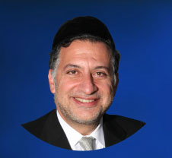

The Ben Ish Hai (Rav Yosef Haim of Baghdad, 1833-1909), in his Od Yosef Hai, offers several fascinating interpretations of the Pasuk at the beginning of Parashat Ki-Tisa – “Ki Tisa Et Rosh Beneh Yisrael.”  The plain meaning of the verse is that it refers to the method of counting the nation, and “Ki Tisa Et Rosh” means, “When you count.”  Literally, however, the words “Ki Tisa…Beneh Yisrael” mean, “When you elevate Beneh Yisrael,” and the Ben Ish Hai suggests several different approaches to explain this notion of “raising” Beneh Yisrael.

One explanation relates to last week’s Parasha, Parashat Tesaveh.  Parashat Tesaveh is unique in that it contains no mention at all of the name of Moshe Rabbenu, and our Rabbis have explained that this omission is the result of Moshe’s request after the sin of the golden calf: “And now, if You will, pardon their sin, and if not, then erase me, please, from Your book which You have written” (32:32).

Although G-d forgave Beneh Yisrael for their sin, a request made by a Saddik must be fulfilled, at least partially, even it was made on condition. Therefore, Moshe’s request to be “erased” was fulfilled through the omission of his name from Parashat Tesaveh.

The Ben Ish Hai explains that Parashat Tesaveh was chosen as the Parasha from which Moshe’s name would be excluded because it is the twentieth Parasha in the Torah.  Moshe had asked to be erased from “Sifrecha” (“Your book”), which can be read as “Sefer” followed by the letter “Chaf,” which would mean, “the twentieth book,” referring to the twentieth Parasha.

The Ben Ish Hai further explained that this omission was done for the purpose of appeasing the Satan.  Beneh Yisrael’s grave sin emboldened the Satan, who vehemently petitioned G-d to annihilate the people.  In order to spare Beneh Yisrael, G-d appeased the Satan by excluding Moshe from Parashat Tesaveh.

There was also another measure taken to satisfy the Satan.  The Torah in the Book of Bamidbar (12:3) describes Moshe as the must humble man on Earth, but the word “Anav” (humble) in that verse is spelled in an unusual manner, without the letter “Yod.”  The Ben Ish Hai explains that this was done as if to qualify the Torah’s praise of Moshe, and suggest that in truth he was not exceptionally humble.  The omission of the letter “Yod” was the second measure undertaken in order to satisfy the Satan so he would no longer advocate for the annihilation of the Jewish People.

With this in mind, the Ben Ish Hai writes, we arrive at a deeper understanding of the phrase, “Ki Tisa Et Rosh Beneh Yisrael.”  The word “Ki” consists of the letters “Kaf” and “Yod,” and thus alludes to Parashat Tesaveh, the twentieth Parasha (the numerical value of “Kaf”), and the letter “Yod” which was left out of the word “Anav.”  These two letters had the effect of “Tisa Et Rosh Beneh Yisrael” – of elevating Beneh Yisrael, protecting them from the efforts of the Satan.  It was through these measures which were taken to satisfy the Satan that Moshe was able to achieve atonement on behalf the Jewish People and ensure their continued existence despite the grievous sin they committed.

*Reprinted from this week’s website of The Edmond J. Safra Synagogue in Brooklyn.*

**The Importance of a Jew**

**Giving Generously and Joyously**

**By Daniel Keren**

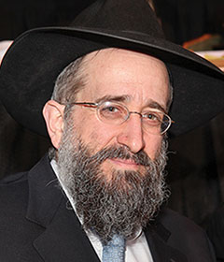

**Rabbi Yisroel Reisman**

Hundreds of men and women took advantage of the recent Presidents Day legal day holiday to participate in a half-day Yarchei Kallah Event at the Agudath Israel of Madison that was organized by Hakhel, a Flatbush-based organization dedicated to promoting a greater awareness of Torah-true values in our community.

The event began with a final lecture on Sefer Divrei Hayomim Aleph (the First Book of Chronicles) by Rabbi Yisroel Reisman, the mora d’asra of the host shul who spoke on the topic of “Dovid Hamelech’s Last Speech.” He noted that Divrei Hayomim was divided into two parts or volumes by the printers. The first volume concludes with the death of King David and the second volume begins with the story of Shlomo Hamelech (King Solomon) and the remaining monarchs of the House of Dovid.

We know that Dovid Hamelech had many very difficult challenges in life. In the words of his last speech that he addresses to the Jewish people in Perek (Chapter) 29, he told his subjects that he had accomplished everything that he wanted to achieve with one important exception - that of constructing the House of Hashem for Hakodesh Baruch Hu had not allowed him to build the Holy Temple in Jerusalem. That was to be achieved by his son Shlomo Hamelech.

Dovid told his subjects that he had personally donated all of the physical materials needed for the construction of the future Beis Hamikdosh. However he then called upon the nation to generously donate the large amount of money that would be needed to pay the workers and for the other important matter related to building and maintaining the Temple.

**King Dovid’s Last Appeal to His Nation**

And Chapter 29 records the dramatic response of the people to Dovid’s last appeal demonstrating that they were happy to have made such an important donation. Even down to this day, Rabbi Reisman noted that Jews are distinguished from among other nations for being overly generous with their donations. And once they have given, they rejoice in having been able to do so. They understand that they were merely agents for Hakodesh Baruch Hu [who had entrusted them with His money.]

This legacy of nevida, giving generously is an inheritance from our forefather Avraham Avinu. Someone who gives tzedaka (charity) is showing a character trait of our patriarchs – Avraham, Yitzchak and Yaakov. This demonstrates that we understand that we are actually [just merely] doing Hakodesh Baruch Hu’s will.

The teaching that in giving money to tzedakah one will be rewarded with riches should be understood that the riches one gains in his life is for the purpose of allowing the Jew to give even more of Hashem’s money for tzedakah.

Dovid Hamelech davens to Hashem to always inspire the Jewish people to enjoy giving generously. Rabbi Reisman quoted from an article in the December 2017 issue of NonProfit Quarterly by Larry Kaplan titled “America’s Jewish Community Leads in Per Capita Giving.” It highlighted the fact that Jews give charity in a much higher proportion than any other ethnic group in the United States.

**Most Wealthy Jews Unfortunately Donate to Non-Jewish Causes**

Unfortunately the same study revealed that most major donations by wealthy Jews (91%) were given to non-Jewish causes. The study analyzed the giving patterns of the 33 Jews who had made the 2016 Forbes list of the richest Americans, concluding that an average of only 11 percent of the giving through their foundations backed exclusively Jewish causes.

Examples included billionaire Stephen Schwarzman’s $150 million gift to Yale University, David Geffen’s same sized gift to the Los Angeles County Museum of Art and George Kaiser, son of Holocaust refugees giving the Tulsa River Parks Authority a gift of $142. In conclusion, Rabbi Reisman sighed that even when donating to charity, a Jew needs proper siyata di’shmaya to give properly and perform a great mitzvah.

The nature of Jews is that they have to be asked for donations, but once asked they will willingly respond with a donation and be happy afterwards for having done so.

Dovid Hamelech’s final words to the Jewish nation are “Don’t forget to praise the Ribono shel Olam (the Master of the World.) Why asks Rabbi Reisman is this so important that this would be his final words or message to the Jewish people?

**The Purposes of Praising Hashem is to Forge a Relationship**

Dovid is the author of Sefer Tehillim (the Book of Psalms) a legacy to Klal Yisroel in which he is constantly praising Hashem. What is the purpose of praising G-d? It is not to butter up Hakodesh Baruch Hu. Rather it is to afford us the opportunity to develop a connection with the Ribono shel Olam.

Parnasah (livelihood,) health, shidduchim (getting married) and the difficulties of raising children are the four primary challenges in our lives. Our lives often become very unhappy because we tend to focus primarily on the difficulties in our lives.

We learn from Dovid Hamelech who had one of the most challenging lives of anyone in this world that one should rather focus on those things which are going well and strive to thank Hashem for the good things in one’s life. And this will make a person happy despite the other seeming difficulties and disappointments in one’s life. That is why King David has been called the “Sweet Singer of Israel.”

Rabbi Reisman declared that G-d is consistent. He is our Father who loves us and everything that He does to us is for our own benefit. This attitude can help every person withstand the seemingly trying times in our lives by giving us the knowledge that everything G-d does to us is because of His love for us and for our own good.

*Reprinted from the March 5, 2020 edition of The Flatbush Jewish Journal.*